C++ Programming Default Arguments (Parameters)

In C++ programming, you can provide default values for [function](https://www.programiz.com/cpp-programming/function) parameters.

The idea behind default argument is simple. If a function is called by passing argument/s, those arguments are used by the function.

But if the argument/s are not passed while invoking a function then, the default values are used.

Default value/s are passed to argument/s in the function prototype.

## Working of default arguments

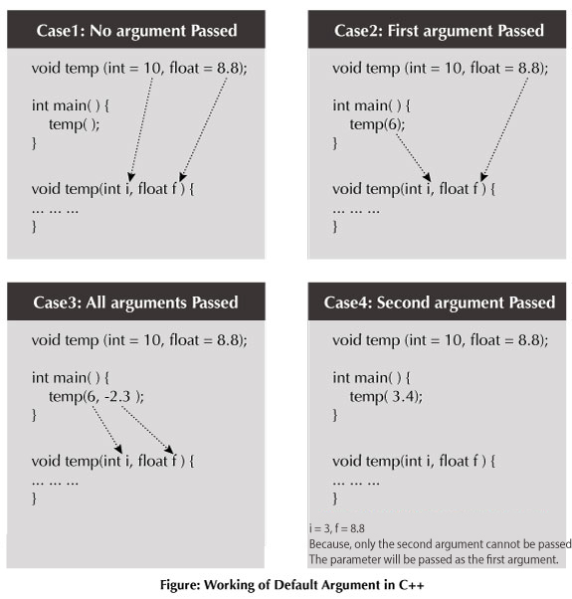

## Example: Default Argument

// C++ Program to demonstrate working of default argument

#include <iostream>

using namespace std;

void display(char = '*', int = 1);

int main()

{

cout << "No argument passed:\n";

display();

cout << "\nFirst argument passed:\n";

display('#');

cout << "\nBoth argument passed:\n";

display('$', 5);

return 0;

}

void display(char c, int n)

{

for(int i = 1; i <= n; ++i)

{

cout << c;

}

cout << endl;

}

**Output**

No argument passed:

*

First argument passed:

#

Both argument passed:

$$$$$